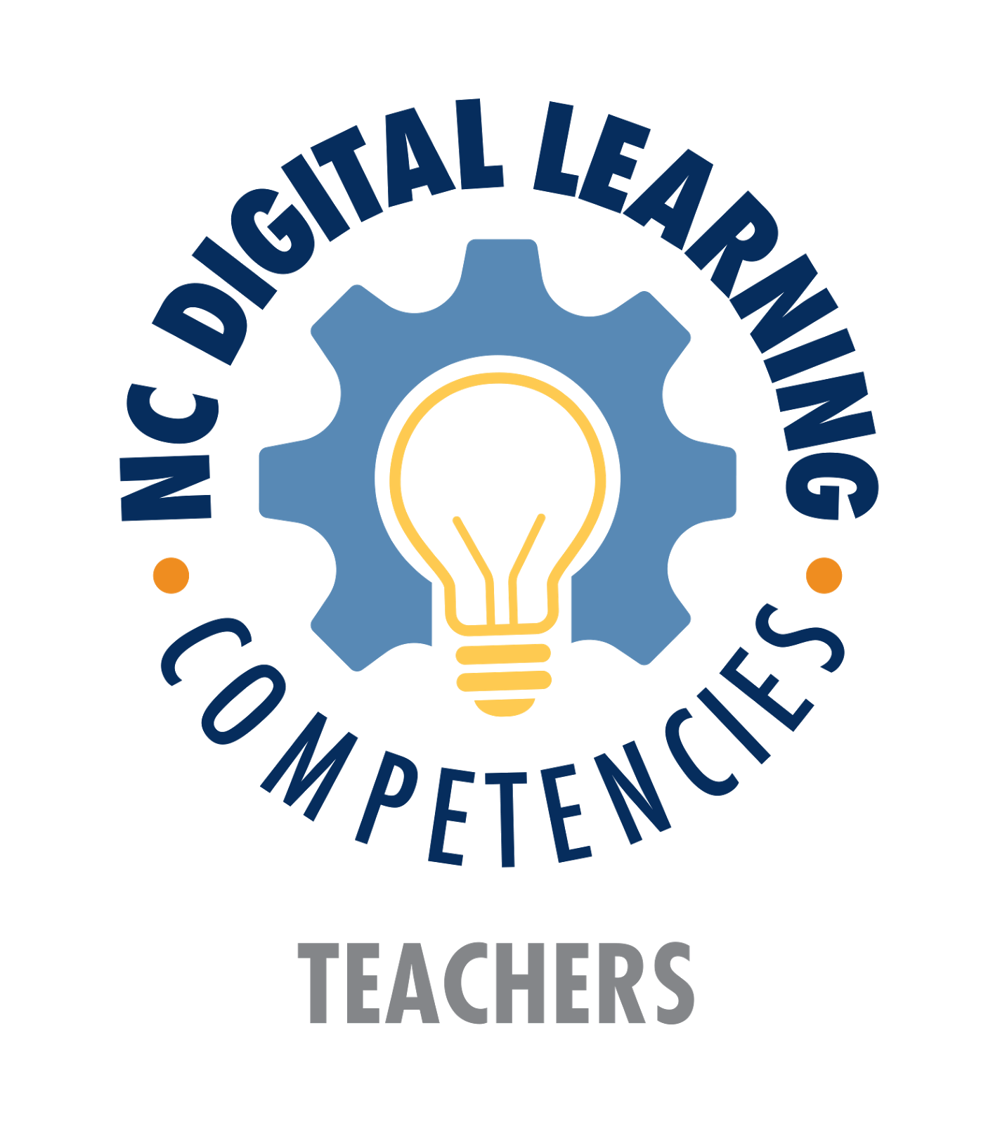
Name:____________________________________________________

SELF-REFLECTION

DIGITAL​ ​CONTENT ​ &​ ​ INSTRUCTION​
Teachers​ ​will​ ​know​ ​and ​​use​ ​appropriate​ digital​ ​​tools ​​and​ ​resources ​​for​ instruction. ​

NOVICE | EXPERIENCED | MASTERY | What is your current level? | For Novice, what do you wish to improve upon? How can you grow (list one example)?  For Experienced or Mastery, how do specifically do you meet this? What is at least one example?
Teachers​ ​sometimes ​ ​utilize appropriate​ ​digital ​ tools​ ​ and​ ​ resources​ for​ ​instructional​ ​use​ ​by... | Teachers​ ​often​ ​utilize​ ​appropriate digital​ ​tools​ ​and​ ​resources​ ​for instructional​ ​use​ ​by... | Teachers​ ​consistently ​ utilize​ appropriate​ ​digital​ ​tools ​ and​ ​ resources​ for​ ​instructional​ ​use...
designing​ ​learning​ experiences​ ​ ​that allow​ ​students​ ​to​ ​explore​ ​relevant issues​ ​and​ ​providing​ ​students predetermined​ ​digital​ ​tools​ ​and resources | designing​ ​learning ​experiences​ ​ that​ allow​ ​students​ ​to​ ​explore​ ​relevant issues ​ ​and​ analyze​ ​ authentic​ problems​ ​through​ ​digital​ ​tools​ ​and resources | designing​ ​learning ​ experiences​ ​ that​ allow​ ​students​ ​to​ ​explore, ​ analyze, ​ and​ ​solve​ authentic​ ​ ​problems ​ and​ encouraging​ ​students​ ​to​ ​personalize learning​ ​by​ ​pursuing ​ ​their​ ​individual interests
identifying ​ appropriate​ digital​ tools​ and​ ​resources ​ to​ ​ teach​ ​ students​ ​ new​ material​ ​and​ ​challenge​ ​students​ ​to create​ ​and​ ​communicate​ ​their​ ​ideas effectively | identifying​ ​and ​ utilizing​ ​ appropriate​ digital​ ​tools​ ​and​ ​resources ​ to​ challenge​ ​students​ ​to​ ​create​ new​ content, ​ ​think​ ​critically, ​ ​solve problems, ​ ​and​ ​communicate​ ​their ideas​ ​effectively | identifying, ​ ​utilizing, ​ and​ ​ ​analyzing appropriate​ ​digital​ ​tools​ ​and​ ​resources to​ ​challenge​ ​students ​ to​ ​ create​ ​ new​ content, ​ ​think​ ​critically, ​ ​solve problems, ​ ​establish ​ reliability, communicate​ ​their​ ​ideas, ​and collaborate​ ​effectively

LEADERSHIP​ ​IN​ ​DIGITAL​ ​LEARNING
Teachers​ ​will​ ​demonstrate​ ​leadership​ ​in​ ​accelerating​ ​their​ ​integration​ ​of​ ​digital​ ​teaching​ ​and​ ​learning pedagogies.

NOVICE | EXPERIENCED | MASTERY | What is your current level? | For Novice, what do you wish to improve upon? How can you grow (list one example)?  For Experienced or Mastery, how do specifically do you meet this? What is at least one example?
Teachers​ ​sometimes​ ​demonstrate  leadership​ ​in​ ​their​ ​integration​ ​of​ ​digital teaching​ and​ ​ ​learning ​ ​pedagogies by... | Teachers​ ​often​ ​demonstrate  leadership​ ​in​ ​their​ ​integration​ ​of​ ​digital teaching​ and​ ​ ​learning ​ ​pedagogies by... | Teachers​ ​consistently​ ​demonstrate  leadership​ ​in​ ​their​ ​integration​ ​of​ ​digital teaching​ and​ ​ ​learning ​ ​pedagogies by...
participating​ ​in​ ​social​ ​networks, face-to-face​ ​or​ ​online​ ​PLCs | participating​ ​in​ ​social​ ​networks, face-to-face​ ​and/or​ ​online​ ​PLCs | participating​ ​in​ ​social​ ​networks, face-to-face​ ​and​ ​online​ ​PLCs
participating​ ​in​ ​professional development​ ​opportunities | participating​ ​in​ ​and/or​ ​providing professional​ ​development opportunities | participating​ ​in​ ​and​ ​providing professional​ ​development opportunities
researching​ ​technology​ ​tools​ ​and investigating​ ​implementation strategies | researching​ ​and​ ​implementing technology​ ​tools​ ​and​ ​effective instructional​ ​strategies | researching, ​ ​implementing, ​ ​modeling, and​ ​promoting ​ technology​ ​ tools​ ​ and​ best​ ​practices
reflecting​ ​on​ ​professional​ ​practice | reflecting ​ on​ ​ professional​ ​ practice​ ​ for​ the​ ​purpose​ ​of​ ​improving​ ​instruction | reflecting​ ​on​ ​professional ​ practice​ ​ for​ the​ ​purpose​ ​of​ ​improving​ ​instruction  both​ ​individually​ ​and​ ​for​ ​the  profession

DATA​ ​&​ ​ASSESSMENT
Teachers will use technology to make data more accessible, adjust instruction to better meet the needs of a diverse population, and reflect upon their practice through the consistent, effective use of assessment. ​

NOVICE | EXPERIENCED | MASTERY | What is your current level? | For Novice, what do you wish to improve upon? How can you grow (list one example)?  For Experienced or Mastery, how do specifically do you meet this? What is at least one example?
Teachers​ ​sometimes​ ​utilize ​ digitally​ enhanced, ​ ​as​ ​well​ ​as​ ​other​ ​various assessment ​ methods, to​ ​ inform​ ​ their​ teaching​ ​practice​ ​by... | Teachers​ ​often ​ utilize​ ​ digitally​ enhanced​ ​and​ ​varied ​ assessment​ methods​ ​to​ ​gather​ ​and​ ​analyze​ ​data through​ ​technology​ ​tools​ ​informing differentiated​ ​instruction​ ​by... | Teachers​ ​consistently​ ​utilize ​ digitally​ enhanced​ ​assessment​ ​methods ​and​ empower​ ​student​ ​utilization​ ​of assessment​ ​data​ to​ ​ ​inform personalized​ ​learning​ ​by...
utilizing​ ​digitally​ ​enhanced​ ​formative and​ ​summative​ ​assessments | utilizing​ ​digitally​ ​enhanced​ ​online assessments ​ to​ ​ gather​ ​ student​ performance​ ​data​ ​to​ ​inform​ ​instruction | utilizing​ ​digitally​ enhanced​ ​ ​online assessments ​ to​ ​ gather​ ​ student​ performance​ ​data ​ to​ ​ inform​ ​ instruction​ and​ ​personalize​ ​student​ ​learning
supplying​ ​performance​ ​data​ ​to students | supplying​ ​performance​ ​data​ ​to students​ ​and​ ​providing  recommendations​ ​to​ ​students ​ ​for improving​ ​performance | supplying​ ​performance​ data​ ​ ​and collaborating ​ with​ ​ students​ ​ to​ ​ analyze​ data​ ​and​ ​guide​ ​students​ ​in​ ​the creation​ ​of​ ​a​ ​personal​ ​learning​ ​plan
utilizing​ ​multiple​ ​and​ ​varied​ ​forms​ ​of assessment | utilizing​ ​multiple​ ​and​ ​varied​ ​forms ​ of​ assessment​ ​including​ ​sample​ ​work products​ ​and ​ evaluating​ ​ against​ ​ a​ standards​ ​aligned​ ​rubric | utilizing​ ​multiple​ ​and​ ​varied​ ​forms​ ​of assessment​ ​including ​ student​ ​ work​ samples, ​ ​evaluating​ ​against​ ​a standards ​ aligned​ ​ rubric, and​ collecting​ ​feedback​ ​through ​ ​an​ ​online community

DIGITAL​ ​CITIZENSHIP
Teachers will model and teach digital citizenship by the ethical, respectful, and safe use of digital tools and resources that support the creation of a positive digital school culture.

NOVICE | EXPERIENCED | MASTERY | What is your current level? | For Novice, what do you wish to improve upon? How can you grow (list one example)?  For Experienced or Mastery, how do specifically do you meet this? What is at least one example?
Teachers​ ​sometimes​ ​model ​ and​ ​ teach​ digital​ ​citizenship​ ​and​ ​the​ ethical, ​ respectful​ ​and​ ​safe​ ​use​ ​of​ ​digital​ ​tools by... | Teachers​ ​often​ ​model​ ​and ​ teach​ digital​ ​citizenship​ ​and​ ​the​ ethical, ​ respectful ​ and​ ​ safe​ ​ use​ ​ of​ ​ ​digital ​ tools​ by... | Teachers​ ​consistently​ ​model​ ​and teach ​ digital​ ​ citizenship​ ​ and​ ​ the​ ethical, ​ ​respectful​ ​and​ ​safe​ ​use​ ​of digital​ ​tools​ ​by...
demonstrating​ ​the​ understanding ​ of​ intellectual​ ​property​ ​rights​ ​and following​ ​copyright​ ​law​ and​ ​ ​fair ​ ​use guidelines | demonstrating​ ​and​ ​explicitly​ ​teaching students​ ​the​ ​understanding​ ​of intellectual ​ property​ ​ ​rights​ ​while  following ​ copyright​ ​ law​ ​ ​and​ fair​ ​ ​use guidelines | demonstrating, ​ explicitly​ ​ teaching​ students, ​ ​and​ ​consistently​ ​requiring the​ ​understanding​ ​of​ ​intellectual property​ ​rights ​ while​ ​ following​ copyright​ ​law ​ ​and​ ​fair​ ​use​ ​guidelines
engaging​ ​in​ ​responsible​ ​and professional​ ​digital​ ​social​ ​interaction | engaging​ ​in​ ​responsible​ ​digital​ ​social interaction​ ​and​ ​explicitly​ ​teaching students ​ digital​ ​ ​citizenship​ ​lessons | engaging, ​ ​teaching, ​ and​ ​ consistently​ requiring​ ​the​ ​use​ ​of​ ​digital​ ​citizenship best​ ​practices​ ​and​ ​responsible​ ​digital social​ ​interaction
demonstrating​ ​global​ ​awareness through ​ providing​ ​ opportunities​ ​ to​ research​ ​other​ ​cultures​ ​via​ ​digital research​ ​tools | demonstrating​ ​global​ awareness​ through​ ​providing​ ​opportunities​ ​to research ​ and​ ​ engage​ ​ with​ ​ other​ cultures​ ​via​ ​communication​ ​tools | demonstrating​ ​global​ ​awareness through​ ​providing​ ​opportunities ​ to​ research, ​ engage, ​ ​ ​and​ ​collaborate with​ ​other​ ​cultures​ ​via​ ​various, advanced ​ communication​ ​ ​and collaboration​ ​tools

