PRODUCTION FUNCTION WITH ALL VARIABLE INPUTS

K | L | 1 | 2 | 3 | 4 | 5 | 6 | 7 | 8 | 9
1 |  | 236 | 928 | 2052 | 3584 | 5500 | 7776 | 10388 | 13312 | 16524
2 |  | 928 | 3584 | 7776 | 13312 | 20000 | 27648 | 36064 | 45056 | 54432
3 |  | 2052 | 7776 | 16524 | 27648 | 40500 | 54432 | 68796 | 82944 | 96228
4 |  | 3584 | 13312 | 27648 | 45056 | 64000 | 82944 | 100352 | 114688 | 124416
5 |  | 5500 | 20000 | 40500 | 64000 | 87500 | 108000 | 122500 | 128000 | 121500

--------------------------------------------------------------------------------------------------------------------------------

GRAPH OF PRODUCTION WITH ALL INPUTS VARIABLE

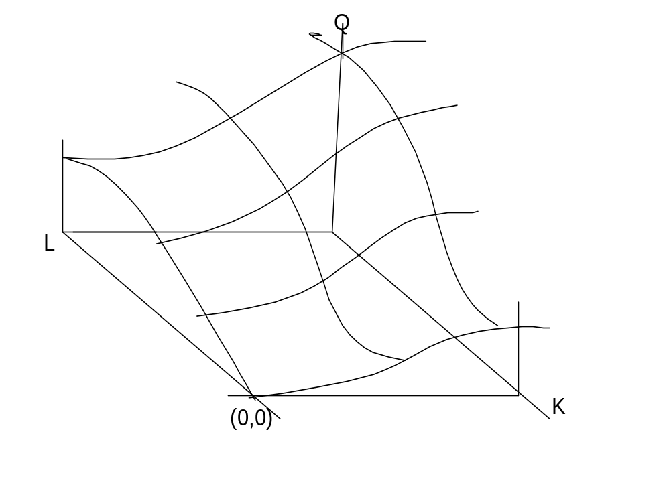

SR Production Function

L Q=TP
0 0
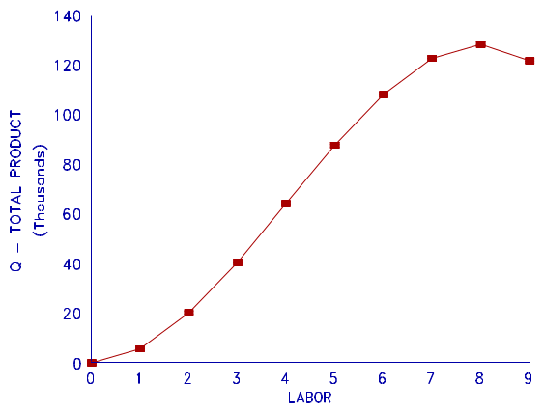

1 5500
2 20000
3 40500
4 64000
5 87500
6 108000
7 122500
8 128000
9 121500

---------------------------------------------------------------------------------------------------------

Tabular and Graphical Examples
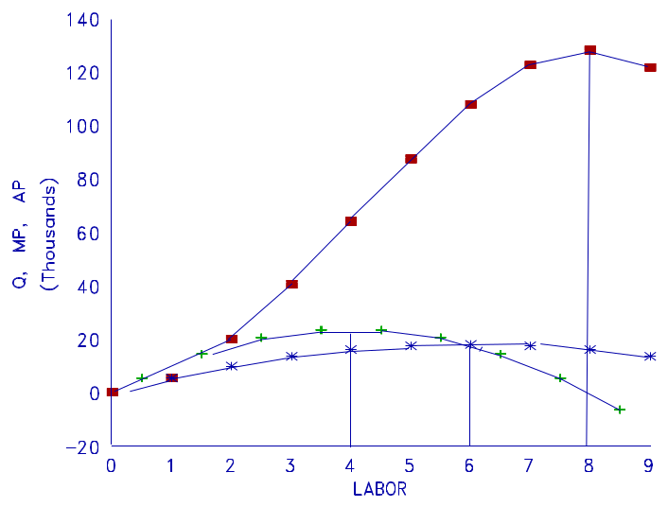
AVERAGE
L Q=TP MP AP
0 0
0.5 5500
1 5500 5500
1.5 14500
2 20000 10000
2.5 20500
3 40500 13500
3.5 23500
4 64000 16000 DMP
4.5 23500
5 87500 17500
5.5 20500
6 108000 18000 DAP
6.5 14500
7 122500 17500
7.5 5500
8 128000 16000 DTP
8.5 -6500
9 121500 13500
9.5 -21500
10 100000 10000
10.5 -39500
11 60500 5500

ISOQUANT MAP
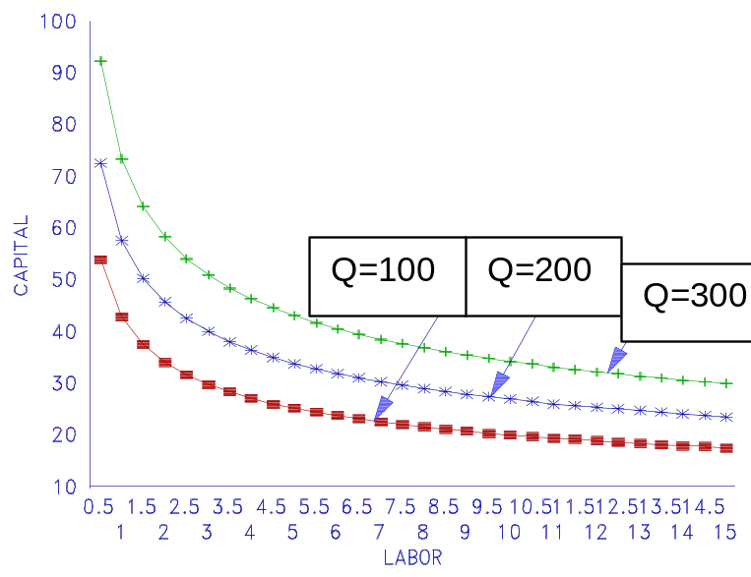

PRODUCTION FUNCTION SOURCE OF ISOQUANTS

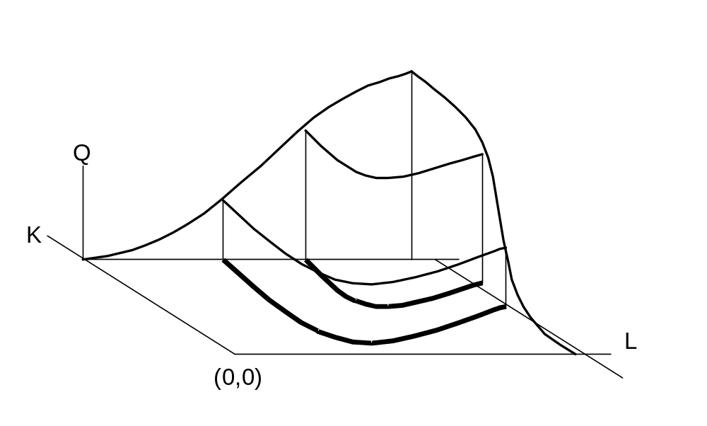

Negative Slope of Isoquants
Diminishing Marginal Rate of Technical Substitution
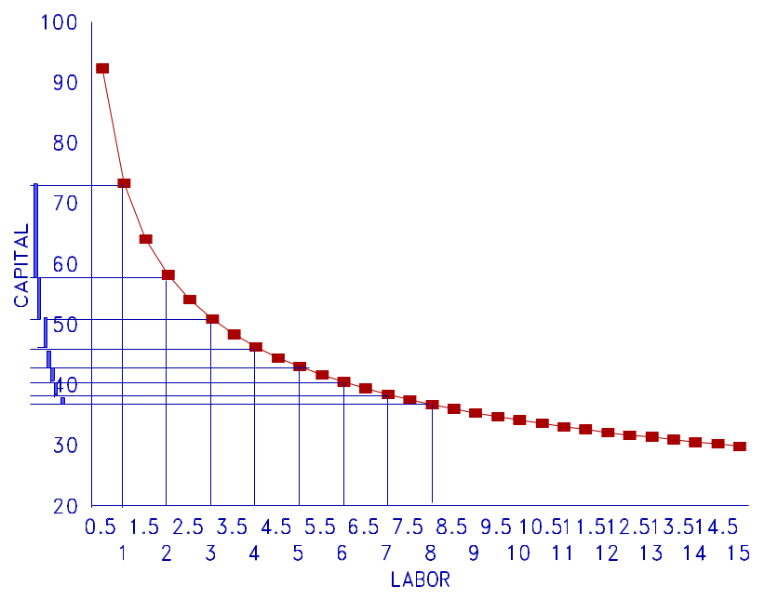

Increasing Returns to Scale
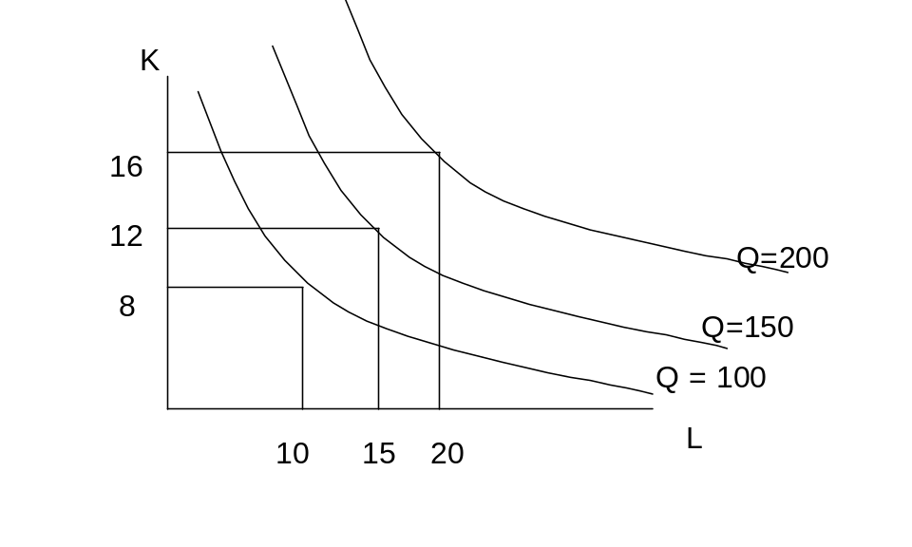

ISOCOST LINE

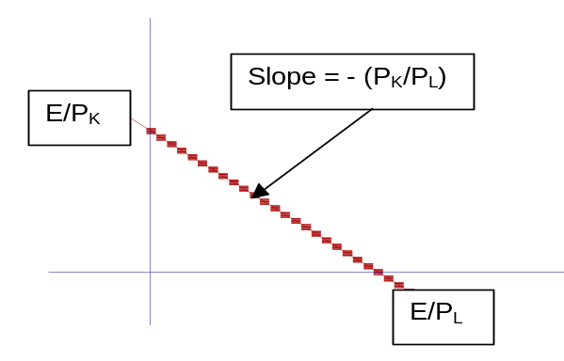

OUTSOURCING EXAMPLE


