# Viewing and Understanding the Assigned e-Learning Lessons

### Viewing Assigned e-Learning Lessons

Managers and administrators of the LMS training system assign your training e-Learning lessons. From your Personal page you can see how many assigned lessons you have pending.

The example below shows four assigned uncompleted e-Learning lessons due and one assigned uncompleted Class & Event pending.

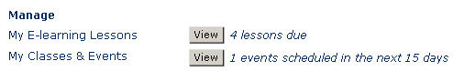

### Opening the Assigned e-Learning Views

Once you open “My e-Learning Lessons” you can view your assigned e-Learning lessons from different views (e.g., All My Lessons). By default, all your uncompleted e-Learning lessons open. If you have the ability to self-enroll in any e-Learning lessons, any uncompleted self-enrolled lessons also display. See Identifying Icons and/or Understanding your Assigned Lesson Views Help.

#### Step to Open Your Assigned Lessons:

* From your Personal Page, click the **View** button to the right of **My e-learning Lessons**.   
  Your “My Assignments” page opens.

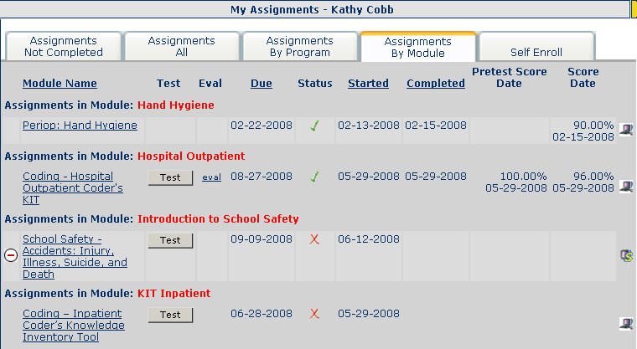

**Note:** You can also use the menu bar and select **e-Learning** – **My e-Learning Lessons** to open your e-Learning lessons.

### Understanding the Assigned Lesson Views

You can view your assigned e-Learning lessons (and self-enrolled e-Learning lessons) in the following multiple views.

**Note**: The self-enrollment feature may not be available for your organization.

**(default) Assignments Not Completed**: Lists all your **incomplete** lessons for both assigned lessons and self-enrolled lessons. Lessons list by Due date.

In the **e- Assignments — Not Completed** example below the Learner is enrolled in one assigned lesson and two self-enrolled lessons. No lessons are completed in this view.

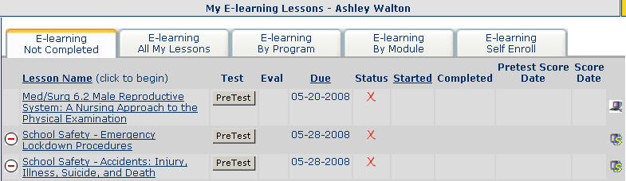

**Assignments — All**: Lists complete and incomplete lessons for both assigned and self-enrolled e-Learning lessons in date order by Due Date.

**Assignments — By Program**: Lists lessons used during assignment by your administrator. If your manager has asked that you complete all of your HIPAA lessons, you could use the Program sort to ensure you have completed all lessons assigned by the HIPAA program.

**Assignments — By Module**: Lists your lessons together by module. Your administrator groups lessons together in a module. There can be any number of lessons inside a module.

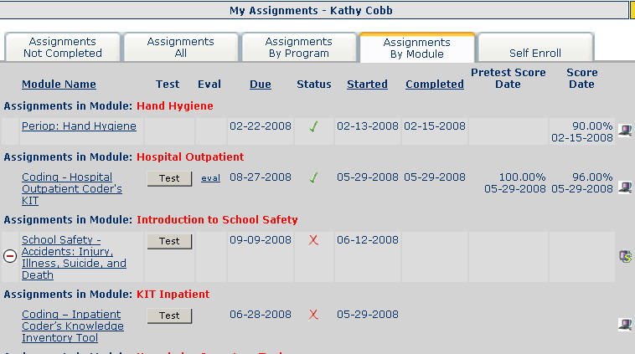

**Self Enroll**: Lists all e-Learning lessons that are available for you to self-enroll in. On this page you have the choice to see what lessons are available to the entire organization, only your facility, only your department, only groups that you belong to, or just for you.

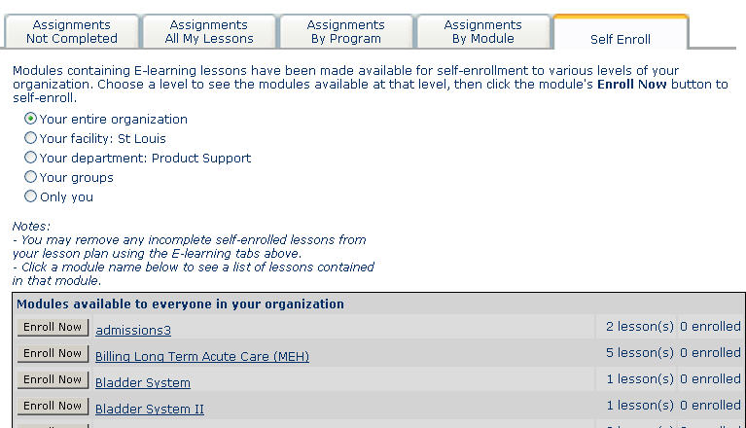

### Understanding Columns from Assigned e-Learning Lesson Views (tabs)

The following columns display on many of the lesson plan views - tabs (e.g., e-Learning All My Lessons).

* **Lesson Name**: The name of the lesson displays as a link. Click a lesson name to start the lesson.
* **Test**: If the Pretest buttons display in the Test column for a lesson, you may have the option to take a Pretest before you take the lesson. Some lessons will require a pretest be taken before the lesson and in those cases, the lesson name will begin with Pre-test – lesson name.
* **Eval**: (Evaluation) When you complete a lesson you should get a link to an evaluation. The link might show as a generic evaluation (eval) or a content specific one (AACN). Once you complete an evaluation after a test, it displays here.
* **Due**: Lessons sort by the Due date (chronological order). When the Due column name is underlined, you can click to sort in reverse chronological order.
* **Status**: Display as either Routine, Medium or High Priority. Your organization defines what is Routine, Medium or High Priority.
* **Started**: Date a lesson starts for the first time.
* **Completed**: Date a lesson is completed.
* **Pretest Score and Date**: If a pretest was taken, the score displays for the pretest along with the date the pretest was taken.
* **Score and Date**: The score displays for the test along with the date the test was taken.
* **Icons**: In the far right column, icons display for each lesson as either assigned lessons (assignedicon ) or self-enrolled lessons (selfenrollmenticon ). You can click an icon to open the key for icons.

**Tip:** Click any underlined column to sort (e.g., Lesson Name).

You can use all the views or just the views you prefer. You can sort lessons based upon the date the lesson must be completed (Due), then, by Status (priority).

**Note**: You may remove any e-Learning Self Enroll incomplete lessons from your lesson plan. To delete a self-enrolled lesson, from the left of the self-enrollment lesson, click the deleteselfenrollmenticon icon.