**Student Orientation**

##### **Manual**

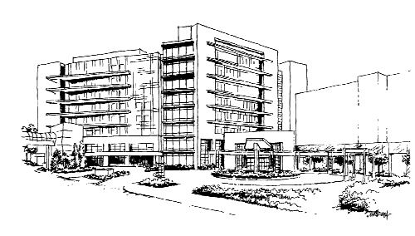

**Welcome to**



## 

## 

Introduction and Welcome to Students

Welcome to the Spartanburg Regional Healthcare System. We value that you have chosen Spartanburg Regional to complete your clinical requirements. We want to do everything we can to make you feel comfortable within our system.

The following pages contain vital information for your safety as well as for the safety of our patients and other customers. Located in the back of your Student Orientation Manual is a ***Confidentiality Agreement***. Read it carefully, complete, and turn in to your clinical instructor or appropriate person as directed.

Spartanburg Regional has a very large campus. We have included an aerial map of the main campus and driving directions. ***The Department of Education*** is always available to answer your questions or to direct you to appropriate department(s) in the event you do not know who to call for specific issues. The offices are located on 4th south of the main hospital and the Tyner Auditorium Education offices (C elevator 3rd floor). We can be contacted at (864) 560-6189 or 560-6282. Cynthia Rice is the liaison for all **nursing students**. Feel free to contact her personally at (864) 809-2122 or 560-6549 if you have any questions or concerns.

Each time you are assigned to a new and unfamiliar clinical area you should locate the Emergency Procedure Manual, Infection Control Manual, Nursing Procedure Manual, IV Procedure Manual, all fire alarms, fire extinguishers, fire escapes and evacuation routes. The manuals are to be used as references as needed and can be accessed on the HUB, the hospital’s Intranet**.**

Please review the Emergency Procedure Manual to identify what to do in the event of a Fire, Tornado, Code 3, Code Pink, Code P.I, Code Trauma, Code Gamma, Hazardous Materials Spill, Safety, and Security Issues.

**Parking for Students:**

Students should park in the Parking Deck on the 4th, 5th, or 6th floors while doing clinicals at SRHS**.**

**Dress code for Students:**

All students are required to adhere to the Spartanburg Regional Dress and Grooming policy. A copy of the policy can be found in the back of the manual.

**Mandatory Requirements for all students practicing at Spartanburg Regional Healthcare System:**

**Note:** All documents should be kept in the student’s file at their school unless

otherwise directed.

Annual Requirements:

1. Completion of health form with immunization record.
2. Completion of OSHA safety requirements (either by completion of modules on the computer or attendance at the SRHS orientation).
3. Completion of the HIPAA education module provided by Spartanburg Regional or documentation of HIPPA education.
4. Signed Confidentiality Form.
5. Criminal Background Check.
6. Copy of current CPR certification card by an American Heart Association sponsored program

Electronic Documentation:

A computer log-in will be issued after instruction from clinical instructor and/or preceptor or after successfully completing designated computer classes offered by Spartanburg Regional Education Department.

## Injury and Exposure Guidelines

Safety in the work environment and prevention of injuries and exposures is everyone’s responsibility. In the event you experience an injury, have an exposure to blood and body fluids (either through the skin e.g., needlestick or onto a mucus membrane e.g., eyes, nose, mouth), or to a communicable disease during your clinical experience at SRHS please follow these steps:

* Perform First Aid. For a splash into eyes, flush with water for 15 minutes. For a needlestick, cut, wound, or splash on mucus membrane (other than eyes), wash the exposed body part with lots of soap and water. Do not use caustic agents (e.g., bleach), antiseptics or disinfectants in the wound.
* REPORT IMMEDIATELY TO YOUR INSTRUCTOR OR PRECEPTOR AND THE DEPARTMENT MANAGER.

* Call Employee Health Office (560-6192) Business hours are Mon-Fri 7a-4pm. After hours call the Nursing Administration Supervisor (560-6000).
* COMPLETE ALL APPROPRIATE PARTS of the S.R.E.O.

(Supervisor’s Report of Employee Occurrence)

* Report to the Employee Health Office with the completed S.R.E.O. located on the 4th floor of the Regional Outpatient Center (suite 400). Do not send the S.R.E.O. form in interoffice mail. A Nurse will perform the initial assessment and provide direction for follow-up as needed. Do not go to the Emergency Center or without prior direction of the EHO office nurse or the Nursing Administrative Supervisor.

In addition to your clinical instructor, all Nursing students should report injuries and exposures to Cynthia Rice, Clinical Liaison Educator (560-6549).

Infection Control Guidelines

INFECTION CONTROL IS EVERYONE’S RESPONSIBILITY. The following information will supplement the program on Infection Control and help you have a safe learning experience at SRHS.

* Infection Control Department

Spartanburg Regional Medical Center-560-6957

Spartanburg Hospital For Restorative Care-560-3065

* Infection Control Manual

Infection Control policies are located in Section 1200 of the Integrated Policy Manual on the HUB.

The *Exposure Control Plans* for Bloodborne Pathogens and Tuberculosis are found in 1200.600 of this section.

* Personal Protective Equipment (PPE)

Locate the PPE on the unit where you are working.

Gloves are available in all sizes.

Each unit will have gowns, protective eyewear, and masks in the clean utility room.

PPE can be disposed of in the regular waste unless heavily soiled with blood or body fluids.

PPE is not to be worn outside the area where it is used.

* Waste Disposal

Waste is separated into three categories:

1. Regular waste in clear bags
2. Infectious waste in red bags
3. Other ie. Chemotherapy

Dispose of all waste in the appropriate containers in the soiled utility room.

Remember: *If it’s red, put it in a red bag.*

All bulk fluid in containers is to be emptied down the toilet or hopper prior to disposal of the container, except for Chest Tube Collection Systems.

Sharps containers are routinely collected by a disposal service. Report any overfilled sharps containers immediately*.*

* Linen

Handle linen as little as possible. Bag all linen at the point of use.

Place all soiled linen in a yellow linen bag, even linen soiled with blood. Double bagging of linen should only occur if there is a risk of fluid leaking through.

All clean linen must be kept covered.

* Cleaning of a Blood Spill

Put on gloves. Soak up the blood spill with an absorbent material (paper towels) and place in a red bag. Disinfect the area with a disinfectant spray found on the housekeeping cart or in the soiled utility room. Notify housekeeper to re-clean the spill area.

* Employee Health Guidelines

In addition, report any possible communicable disease, weeping or open wounds, or rash that you may have to your clinical instructor, department supervisor, and Employee Health. Examples may include: chickenpox, herpes lesions (cold sores and shingles), conjunctivitis, and flu.

Report to your clinical instructor, department supervisor, and Employee Health any rash or severe irritation that develops on your hands as a result of wearing gloves. The Employee Health Manual located on the HUB is another source of information.

* Hand Washing (Hand Hygiene)
  + Hand Hygiene is the most important means of Infection Control.

Keep fingernails short enough to wash under. Nail polish, if worn, should not be chipped, but kept in good condition. Artificial Nails are not allowed in clinical areas. Waterless hand wash is available and may be used at any time if hands are not visibly soiled. .

Information Sheet

Emergency Codes

Dr. Red: Fire

Code 3: Cardiopulmonary Arrest

Code PI: Personal Injury (visitor or outpatient non life-threatening injury such as a fall, etc.)

Code Pink: Infant Abduction / Pediatric Abduction

Code Adam: Visitor reports missing child

Code Trauma: Trauma victims expected in ED

Prepare for Expansion: Disaster Plan has been implemented

Code Gamma: Radiation Emergency Accident victims expected in ED

Emergency Operator: Call 3333 on any house phone. Call the emergency operator to report a Code 3, Code PI, Dr. Red., Code Pink, and Code Adam.

Security: Dial 66333 on any house phone. Call Security any time you need the assistance of a security officer. Also call Security in the event of a mercury spill.

Risk Management

Spartanburg Regional Medical Center – 560-2116

Spartanburg Hospital for Restorative Care – 560-3065

Liability-Defined as a Visitor Injury

Steps to follow:

1. Make sure the visitor is OK.
2. Page a Code PI (3333)
3. Do not force anyone to go to the Emergency Department. It must be their decision.
4. If the injured person asks, “How will my treatment for this injury be paid for?” You say, “I’m not sure.” I’ll take down the information and pass it on to Risk Management.”

Notify Risk Management immediately 560-2116 if there is serious injury.

1. A member of our Security staff will complete the Variance Reports.

They will need your assistance if you saw the incident occur or if you were the first one on the scene.

NOTE: If you see spills, clean them up immediately or call Environmental Services 560-6203

Medical Liability- Defined as Patient Injury

Steps to follow:

1. Injury/medication error, surgical mishap, etc. Notify your clinical instructor, preceptor, and department supervisor. Document factual information

in the patient’s medical record.

Medication A stopped, Medication B started, Doctor notified.”

Never chart in the patient record-“Variance Report was completed.”

1. Assist the staff member in documenting the variance in Midas answering the questions as indicated. Call Risk Management (66927) to discuss in

detail if variance resulted in a patient injury.

1. Do not make notes regarding the incident for your personal records. All written documentation should be in Risk Management. The Variance Report is sufficient. If additional notes are made they must be attached to the occurrence report. Never keep a copy for yourself.
2. If a lawyer calls you or anyone other than a SRMC employee regarding any incident, which occurs while you are at SRMC, do not discuss with them but call Risk Management immediately. Page 253-7679, 24 hrs/day 7 days/ week.

Safe Medical Devices

1. Any problem with equipment, which caused problems for a patient, must be reported by Risk Management to the FDA within ten days. Always save the equipment and any packaging.
2. All equipment must be checked by the hospital’s Biomedical Engineering Department prior to implementing or installing new equipment on the nursing unit.
3. Other supplies that cause injuries such as feeding tubes that rapture or tears must be kept for the Risk Management Department. (Save the packaging and send also.)
4. Malfunctioning equipment should be sent to Biomedical Engineering with a note as to the problem that was experienced. They cannot help if they do not know what the problem is. Do not continue to use malfunctioning equipment.

5. Be conscious of both the patient and equipment. Call Risk Management

immediately if a patient is injured. Source: Safe Medical Device Act 1990

Preventing Allegations of Sexual Misconduct

* Have a third person of the same gender as the patient present during assessment, examination or care of the patient. Do not have a family member as the chaperone.
* Conduct consultations in privacy but not behind closed or locked doors.
* Confront patient in presence of third party if patient demonstrated sexually aggressive behavior.
* Consider cultural and diversity norms for the patient. A hug for some patients may be acceptable by some patients and not for others.
* Be aware of your nonverbal communication and how it might be perceived.
* Avoid meeting with the patient outside the hospital unless accompanied by a third party.
* Be careful of using language or descriptions with sexual overtones.

Lost and Found

1. A safe is available for locking patients valuables in the Cashiers Office 8:30 am-5:00 pm and in the Admitting Office after 5:00 pm.
2. Valuables should be sent home with the family as soon as possible. Note on the medical record the name of the family member and describe the valuable they took home.
3. Valuables are noted on the Valuables Form, placed in the Valuables envelope and a copy of the form is placed on the patient’s chart. When the patient is ready for discharge the chart copy is given to the patient to be taken to the Cashier’s Office or Admitting Office for retrieval.
4. If the policy is not followed such as documenting the patient was advised to lock up valuable or send home with a family member, documenting patient was given a denture cup, and ensure the assignment of benefits was signed, missing valuables may have to be replaced by the hospital, this is charged to the department where they were lost.

Corporate Integrity and HIPAA

The goal of Corporate Integrity is to assist employees, students and contract staff of SRHS in doing the right thing. The right thing includes, but is not limited to: compliance with all laws, rules, and regulations related to healthcare; policies of SRHS; and the basics of good common sense. If you feel that compliance to specific rules and regulations are not being followed, notify your instructor, supervisor, and/or department manager. Also, feel free to call the Hotline number listed below to report any non-compliance issues. Please sign the Confidentiality Agreement to assure that you will be compliant with all patient confidentiality issues.

**The Hotline number is (877) 298-7747.**

**This anonymous, toll-free hotline is available Monday-Friday, 9am – 8pm.**

|  |  |  |  |
| --- | --- | --- | --- |
| **Event/Codes** | **Description** | Initial Response | **Secondary Response** |
| ***Bomb Threat*** | Notification of a bomb by outside caller | Prolong conversation to obtain details about caller & threat  Do not touch if found. | SRMC Security #66333  Off Campus-call 911 |
| “Code 3”  *Cardiac Arrest* | Cardiac/Respiratory arrest. | Call 3333 to activate Code Team. -Initiate CPR  Off Campus- 911 | Code Team, MD |
| “Code Jr.”  ***Pediatric Cardiac Arrest*** | Cardiac/Respiratory arrest. | Call 3333 to activate Code Team. -Initiate CPR  Off Campus- 911 | Code Team, MD |
| **“Prepare for Expansion,”*****External Mass Casualty Disaster*** | # of expected patients.  Phase 1 – 16-35  Phase 2 – 36-100 Phase 3 – 101-300  Phase 4 – over 300 | Remain in department  Prepare for a possible influx of patients in your area. | Manager sends list of available employees & equipment to Command Center |
| **Fire** **“Dr. Red”** | Fire, smoke or smell of something burning | **R=Rescue**  **A=Alarm-pull station**  **C=Contain-close doors**  **E=Extinguish** | **O2 shut off**  **or evacuation as required.** |
| **“Dr. Red Horizontal or Vertical Evacuation** | Horizontal evacuation-move to adjacent smoke compartment  Vertical evacuation-down and possibly out of building | Evacuate ambulatory, wheelchair, and then bedridden patients, taking records if safety permits. | Account for all patient, visitors, and staff. |
| **Hazardous Material Spill** | Any spill which presents a hazard to people or environment (chemotherapy, mercury, radioactive agent) | Immediate first aid-  Call SAFETY LINK at 6-SAFE (6-7233) for a Material Safety Data Sheet (MSDS)  Call Security 66333 | Evacuate area, avoid contact  Complete SREO form and report to Employee Health as appropriate. |
| **Workplace Violence or Security Concern** | Workplace violence or security related incident develops or appears imminent | Call Security 66333 | Remain calm & follow directions of Security & Public Safety |
| **Hostage Situation** | An individual being held against their will by armed perpetrator | Clear area  Call Security 66333 | Remain calm & follow directions of Security & Public Safety |
| **“Code Pink”** | A newborn is missing or known to be kidnapped. | Call Security 66333  Report to nearest exit and, if safety permits, secure the exit. | Give information/ descriptions to Security /Public Safety |
| **“Code Adam”** | Child Abduction: A child is missing or known to be kidnapped | Call Security 66333  Report to nearest exit and, if safety permits, secure the exit. | Give information/ descriptions to Security /Public Safety |
| **“Weather Alert”** | Severe Weather/Tornado conditions by overhead page announcement | Close windows, blinds, and drapes. Move patients / visitors away from windows.  Cover patients with blankets & pillows. | Security watch  Off-site monitor weather radio/TV |
| “Code Trauma” | Trauma patient(s) | Trauma Team activated | None |
| **“Code PI”** | Visitor/Outpatient/Employee injury or fall | Call 3333 | Wait with injured party until Code PI Team responds |
| **Elevator stopped between floors** | Elevator alarm bell will sound. | Call Facilities 66228 | Keep verbal contact with occupants. Reassure them until help arrives. |

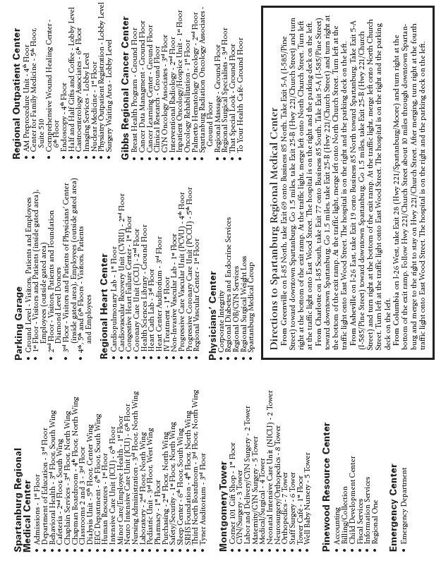

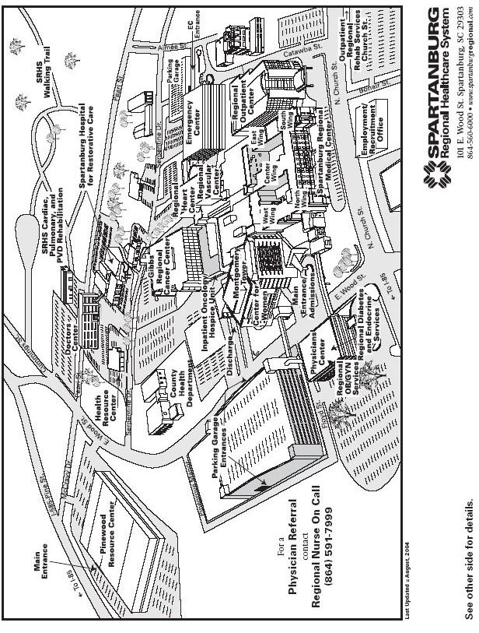

CONFIDENTIALITY AGREEMENT

**SPARTANBURG REGIONAL HEALTHCARE SYSTEM**

**NAME: _______________________________________SCHOOL: ______________________________**

**PATIENT INFORMATION**

Patients have a right to privacy. They have a right to expect that details of their condition, treatment, and medical history. Personal and financial affairs will be kept confidential by all hospital employees and agents. It is not for an employee or agent to decide what information a patient would not object to having disclosed, for what one person considers another may consider being unimportant highly sensitive or embarrassing.

I understand that all information (written, verbal, electronic, or printed) concerning a patient’s medical condition or relating to or referring to a patient’s medical records, regardless of how such information is obtained, is confidential medical information. I agree not to disclose or discuss such information with anyone other than those individuals directly involved in the care of the patient or others with a legitimate business reason to know the information.

**CONFIDENTIAL BUSINESS INFORMATION**

I acknowledge that certain business information of SRHS is considered confidential information. Such confidential information includes patient or vendor lists, public relations and marketing information, patient account information, training and operations material, memoranda and manuals, personnel records and manuals, cost information, and financial information concerning or relating to the business, accounts, patients, employees, agents and affairs of SRHS. I acknowledge and agree that such information is the property of, and confidential to, SRHS, and further, that I will not publish or disclose, either directly or indirectly, any confidential information of SRHS.

**ELECTRONIC/COMPUTER SYSTEMS**

Electronic and computer systems include all computer-generated or stored data, voice mail, facsimile, and electronic mail services. The information transmitted by; received from, or stored in these systems is the property of Spartanburg Regional HealthCare System (“SRHS”). I hereby consent to SRHS monitoring my use of its electronic and computer systems at any time. I understand that such monitoring may include the printing and reading of all electronic mail entering, leaving, or stored in these systems.

I understand that electronic and computer systems are to be used solely for SRHS purposes and agree not to copy, modify or otherwise access the software without the appropriate written authorization. I further agree not to circumvent my password or security level. I acknowledge that software is protected by a variety of licensing agreements and laws and that any misuse of the software may subject me to legal liability as well as disciplinary action up to and including termination from hospital learning experiences.

I understand that any violation of this Confidentiality Agreement may result in disciplinary action, up to and including termination from hospital learning experiences. I understand that SRHS may have additional rights and remedies available to them in law or equity in cases of a disclosure of trade secrets or proprietary information.

_________________________________________________ _______________________________

Signature Date

1/2007

SPARTANBURG REGIONAL HEALTHCARE SYSTEM

POLICY STATEMENT

**TITLE:**

Dress and Grooming

**PURPOSE:**

The purpose of this policy is to have employees present a professional image to internal and external customers while maintaining a safe environment.

|  |  |
| --- | --- |
| **ORIGINATION DATE:** | **KEYWORDS:** |
| 08/12/74 | Dress; Grooming; Nails; Artificial Nails |
| **REVISION DATES:**  06/19/77, 12/01/80, 07/05/88, 08/22/88, 09/26/88, 07/29/91, 08/26/91, 05/19/97, 02/24/98, 06/20/00, 08/15/00, 12/23/02, 01/16/03, 02/06/03, 02/05/04, 10/04/04,  03/04/08 | **REVIEW DATES:**  02/28/94, 01/28/02, 02/03/05 |

**RESPONSIBILITY:**

It is the responsibility of each employee to adhere to this policy and management to enforce.

**POLICY:**

Spartanburg Regional strives to be a highly specialized healthcare organization, whose employees are dedicated, professional people interested in delivering quality care. Employees shall dress and groom in a manner that reflects the highest professional standards to those we serve and with whom we work.

It is the responsibility of the departmental managersto determine if an employee is properly dressed for work. Employees reporting to work in violation of this or other reasonable standards of professional appearance may be sent home without pay and expected to return to work in acceptable attire. Repeated violators may be subject to disciplinary action up to and including termination.

The Department Manager may make exceptions to the Dress Code guidelines listed below when it is appropriate to the working condition of the particular area of which the employee works. It shall be the Department Managers responsibility, however, to see that the employee presents the best possible appearance for customers.

Special consideration may also be given to Spartanburg Regional employees for certain events or holiday theme wear with advanced approval by the Department Director. Dates and specific guidelines shall be communicated to employees. (I.e. Christmas uniforms worn during Christmas holidays)

**Minimum Dressing and Grooming Standards are listed below:**

1. Identification badges
   1. Worn with picture and name visible
   2. Worn above the waist for easy identification
   3. Not defaced with pins and stickers
2. Personal clothing and uniforms should be clean, neat and follow departmental guidelines.
3. Personal Protective Equipment (i.e. shoe covering, cover gowns, mask, etc.) should not be worn outside the individual work area.

4. Hair and beards should be clean and neatly trimmed.

5. Personal hygiene (dirty fingernails, body odor or strong cosmetics and scents) should not be offensive.

6. Length and type of fingernails:

* 1. Should not prevent a job from being done efficiently, safely or with proper hygiene.
  2. Artificial nails are not permitted on an employee providing direct patient care.
  3. Nail polish is discouraged in patient care areas, and when worn, should not be chipped or peeling.
  4. Long natural nails are not allowed. You may be asked to trim your nails by your manager or Infection Control.

7. For the safety of patients and employees, refrain from wearing large earrings and long hanging jewelry. Jewelry worn on the fingers and wrist should be minimal.

8. No pierced ornaments should be worn in visible site other than the ear.

9. Direct caregivers shall wear hair pulled away from their face.

10. The following list is not allowed as professional clothing:

a. Shorts, skorts, tank tops, T-shirts, *denim, halter tops, bare midriff shirts or shirts that expose the midriff at any time, leggings, stretch pants, low riding baggy pants, and warm up suits. (Employees who change into scrub suits may wear casual attire such as warm up suits and jeans as deemed appropriate by the department director. *

b. Crop, Capri and Gaucho pants (except on Business Casual Friday)

c. Tight fitting clothing

d. Clothes with messages

* 1. Skirts more than four inches above the knee
  2. Visible tattoos
  3. Sundresses without a jacket
  4. Flip flops

* The use of denim should be limited to apparel with authorized Spartanburg Regional representation on casual Fridays or to authorized theme days permitting denim apparel.

11. Uniform guidelines must be followed:

a. Employees must follow the departmental uniform guidelines pertaining to colors for their area and job function.

b. Employees in uniform pants may wear shoes either with socks or with hose.

c. Employees in uniform skirts and dresses should wear shoes with hose.

12. Certain shoe types are required for safety:

a. Clinical areas, defined as having patients or specimens in the area, must wear closed toed shoes.

b. Other support areas defined as not having patients or specimens may wear open toed shoes.

* Pantyhose / Stockings are not required unless they are part of the designated departmental uniform.

13. Customary formal business attire is expected for areas with outside contacts, visitors and/or clients within the hospital.

Friday Business Casual Day may serve as a designated day, occurring on a regular basis, when employees may work in clothes which are less formal than those required during their normal work hours. Employees required to wear uniforms for clinical and or safety reasons may not be eligible to participate in these designated days.

Guidelines:

* Employees must maintain a positive, professional image to outside customers, patients, visitors, and guests while dressed in “Business Casual” attire. (The use of denim may be limited to apparel with authorized Spartanburg Regional representation on casual Friday’s, or to authorized theme days permitting denim apparel.)
* Formal business attire should still be required for meetings and contact outside the system or with visitors within the system.
* If there is a question as to what is appropriate attire, employees are encouraged to ask their managers prior to wearing the questionable attire.

**RESOURCES/REFERENCES:**

IM1200.406 - Hand Hygiene