Installing Vensim PLE on Windows XP

1. Launch ‘Internet Explorer’.
2. Enter http://www.vensim.com/venple.html in the address bar and press enter.
3. Click the link labeled ‘download Vensim PLE here’.
4. Click the link labeled ‘Free Downloads’.
5. Enter your name and e-mail address in the appropriate fields, then scroll to the bottom of the page and click ‘Submit info and download software’.
6. Click ‘Disk 1 (Setup)’
7. When File Download dialog appears, click ‘Save’.
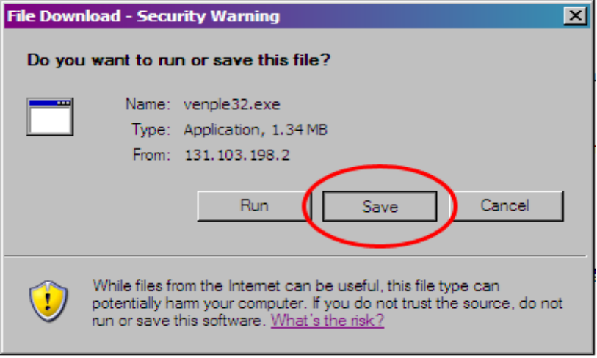
8. When the Save As dialog appears, click the ‘Desktop’ icon on the left and then the ‘Save’ button in the lower right. This will save the program to your desktop.
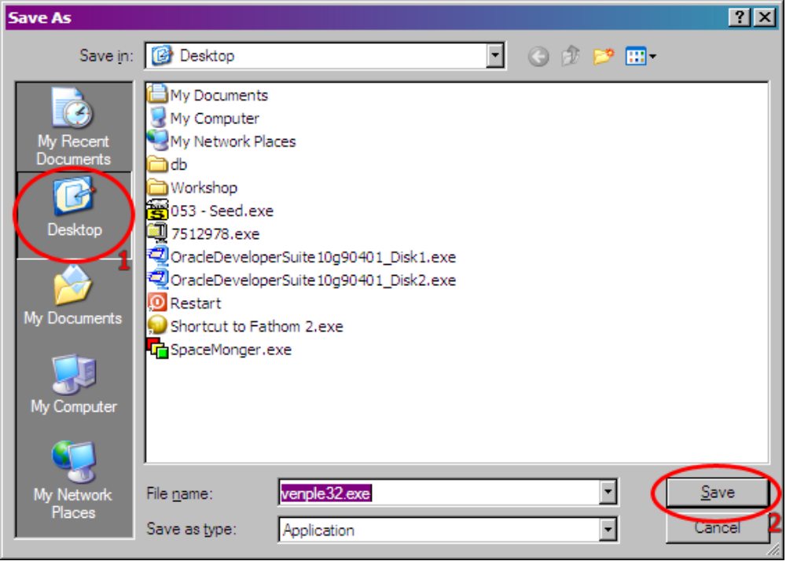
9. Repeat steps 6 through 8 for ‘Disk 2’, ‘Disk 3’, ‘Disk 4’, ‘Disk 5’ and ‘Disk 6’. Don’t worry about cluttering your desktop with these files, you can delete them once the installation has been completed.
10. Double-Click the ‘venple32’ icon now located on your desktop.
11. Click the ‘Next’ button to begin the install.
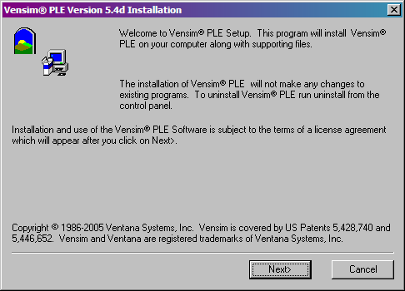
12. When the License Agreement screen appears, click the ‘Yes’ button.
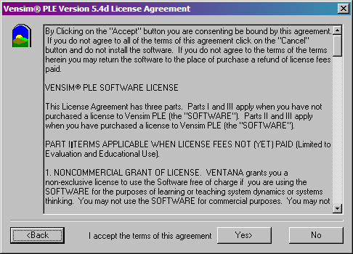
13. From the Install Options, choose ‘Install Vensim PLE for learning and personal use only’ and click Next.
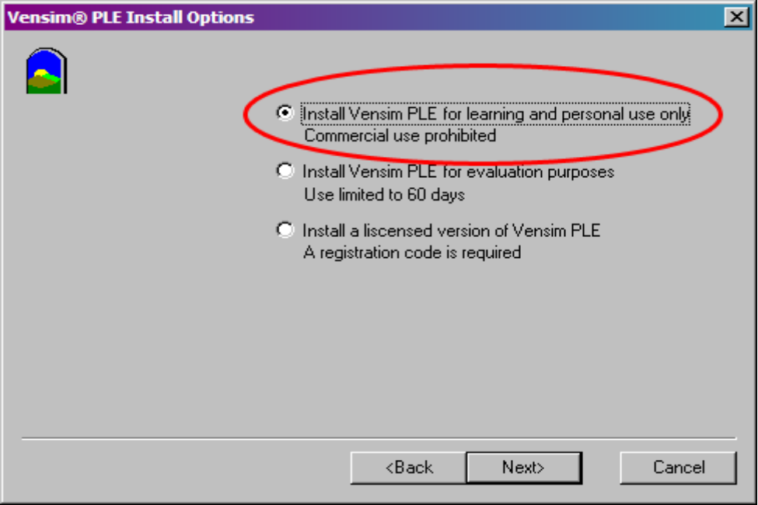
14. Enter your name in the field provided and click ‘Next’.
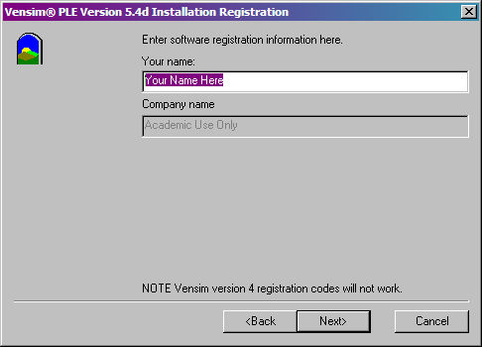
15. Click ‘Next’ to install the program to the default directory.
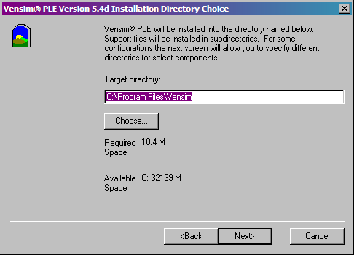
16. If you downloaded all of the supplemental disks during step 9 above, all of the items seen below should be checked. Click ‘Next’
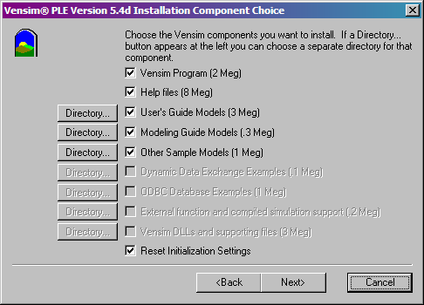
17. You will now be asked to choose which program group in the Start Menu you wish to add the Vensim shortcuts to. The default of Vensim should be fine. Click ‘Install’ to begin the installation.
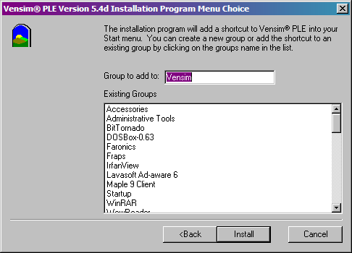
18. Installation is complete. You may now click ‘Start Vensim PLE’ if you wish to run the program now, or simply click ‘Close’ if you wish to exit the installer without running Vensim.
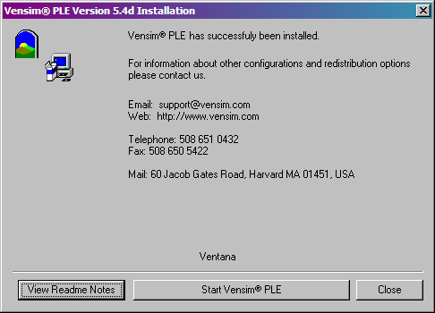
19. You may now delete the setup files that you previously downloaded to your desktop.


